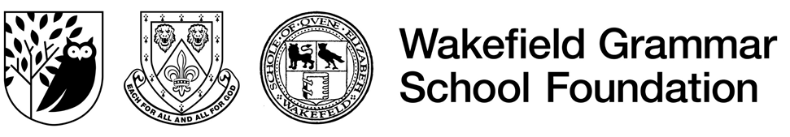
GENDER PAY GAP REPORTING – FOR APRIL 2025

Wakefield Grammar School Foundation (WGSF) is committed to fostering an inclusive environment that ensures fair and equitable remuneration for all staff. This report satisfies the statutory requirements of the Equality Act 2010 (Gender Pay Gap Information) Regulations 2017, which require employers with 250 or more employees to publish specific annual figures regarding their gender pay gap.

Note on Equal Pay: The gender pay gap is a measure of the difference between the average hourly earnings of men and women across the entire Foundation. It is distinct from "Equal Pay," which is the legal requirement that men and women be paid the same for the same or similar work. WGSF remains confident that its pay structures (including national teaching scales and support staff job evaluations) ensure equal pay for equal work.

Headline Data and Three-Year Trend
The following figures represent the Foundation’s progress over the last three reporting cycles.

The following gender pay gap calculations are based on pay which employees received in April 2025.

 | April 2025 | April 2024 | April 2023 | Trend
Mean Gender Pay Gap | 14.55% | 17.32% | 17.45% | -2.77% (Improving)
Median Gender Pay Gap | 11.16% | 24.65% | 28.57% | -13.49% (Improving)
Mean Bonus Gap | N/A | N/A | N/A
Median Bonus Gap | N/A | N/A | N/A

The regulations require the mean and median to be calculated based upon an individual’s hourly rate of pay.

The ‘mean’ provides the ‘average’ figure, where the female and male hourly rates are all added together and then divided by the number of female and male staff respectively.

By contrast the ‘median’ is the middle value in any list of numbers. If all staff lined up in a female line and a male line, in order of pay from highest to lowest, the median gender pay gap compares the hourly pay of the female in the middle of their line and the hourly pay of the male in the middle of their line.

Bonus payments are not given at the Foundation.

Based upon the April 2025 payroll 321 employees were paid.

The proportion of males and females in each quartile pay band

Employees were ranked in order of their pay from lowest to highest, and this range was then divided into 4 groups, all containing 80 colleagues, with the exception of Quartile 4 which has 81 colleagues, in order to show the gender profile across the Foundation.

The number of men and women in each quartile of the pay range is as follows:

Pay Quartiles Split by Males & Females

 | Males | Females
Lower | 19% | 81%
Lower Middle | 34% | 66%
Upper Middle | 42% | 58%
Upper | 49% | 51%

 | Number of Males | Number of Females
Lower | 15 | 65
Lower Middle | 27 | 53
Upper Middle | 34 | 46
Upper | 40 | 41
Total | 116 | 205
The data shows a significant narrowing of the median gap from 28.57% (2023) to 11.16% (2025).
- Occupational Segregation: The gap is primarily driven by the high concentration of female employees in the lower quartiles (74% female). These roles often include term-time-only support functions (e.g., catering, cleaning), which are traditionally more attractive to women seeking flexible working patterns.
- Senior Parity: Progress is evident in the Upper Middle and Upper quartiles, where the gender split (34/46 and 40/41 respectively) closely mirrors or even favours women, reflecting a strong representation of female leaders and senior teachers.

In line with best practices and upcoming requirements of the Employment Rights Act 2025, WGSF is committed to the following actions:
- fair and equitable remuneration and reward: The Foundation remains committed to fair and equitable remuneration and reward and that this is reflected in our policies and practices.
- Recruitment: We will continue to review our job advertisements to ensure gender-neutral language and promote flexible working for all roles to attract a diverse candidate pool.
- Professional Development: We provide equal access to CPD for both teaching and support staff to encourage internal progression into higher pay quartiles.

Statutory Statement of Accuracy
I confirm that the gender pay gap data contained in this report is accurate and has been calculated in accordance with the requirements of the Equality Act 2010 (Gender Pay Gap Information) Regulations 2017.

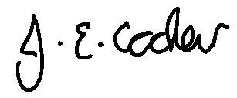

Jenny Cocker
Director of Finance & Operations

March 2026

